OSP SKILL 3
CODE
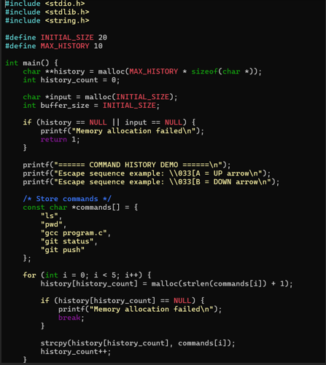
OUTPUT
